UNIT I
MATRIX ALGEBRA
MATRIX
A matrix is a rectangular array of numbers or functions enclosed in brackets. These numbers are called entries or elements of the matrix. The horizontal lines are called the rows and the vertical lines are called the columns of the matrix. If a matrix has numbers or functions arranged in m rows and n columns then the order of the matrix is m×n. If m=n then it is called a square matrix.
Example:-
$$\left[\begin{matrix}2 & -1 & 3 \\ 1 & 0 & 2 \\ 5 & -6 & 4\end{matrix}\right]$$
The term matrix was introduced by Cayley in 1860.It has various applications:-
- Solution of linear system of equations.
- Generation of Codes.
- Quantum Mechanics.
- Electrical Networks.
- Curve fitting and transportation problems. which are also easily amenable for computers.
COEFFICIENT OF MATRIX
For a linear system of equations in x,y,z if the co- efficient of x,y,z are the entries of a matrix whether in rows or columns then that matrix is called a co- efficient matrix.
Example: Find the Co-efficient matrix to the linear system.
5x – 2y + z = 0,
3x+4z = 0
Sol^{n} :- $[\begin{matrix}5 & -2 & 1 \\ 3 & 0 & 4\end{matrix}]$

Vector
A vector is a matrix that has only one row or one column .For a row it is a row vector and for a column it is a column vector.
Example:
A = [a₁ , a₂ , a₃, a₄, ….. , a_{n}]
B = $\left[\begin{matrix}b1 \\ b2 \\ . \\ bn\end{matrix}\right]$
Transposition:
If A = [a_{ij}] is a mtrix of order m $×$ n then transpose of A is defined as A^{T} = [a_{ji}] of order n $×$ m that is
A^{T} = $\left[\begin{matrix}A11 & A21 & … & Am1 \\ A12 & A22 & … & Am2 \\ … & … & … & … \\ An1 & An2 & … & Amn\end{matrix}\right]$
Equality of Matrices:
Two Matrices A and B are said to be equal that A = B if they have same ordered and the corresponding entries are equal that is
A₁₁ = B₁₁, A₁₂ = B₁₂, ……
Addition of Matrices:
If A = [a_{jk}] and B = [b_{jk}] are two matrices of same size then their sum is A+B = [a_{jk} + b_{jk}]
Example:
A = $\left[\begin{matrix}-4 & 6 & 3 \\ 0 & 1 & 2\end{matrix}\right]$ , B = $\left[\begin{matrix}5 & -1 & 0 \\ 3 & 1 & 0\end{matrix}\right]$
A + B = $\left[\begin{matrix}1 & 5 & 3 \\ 3 & 2 & 2\end{matrix}\right]$ #Don’t Be Lazy Bro You Know the Addition.
Scalar Multiplication:
Scalar multiplication is the operation of multiplying a vector or matrix by a single real number (called a scalar), which scales its magnitude (length) without changing its underlying line of direction.
Example: 2 $×$ $\left[\begin{matrix}1 & 4 \\ 2 & 5\end{matrix}\right]$ = $\left[\begin{matrix}2 & 8 \\ 4 & 10\end{matrix}\right]$
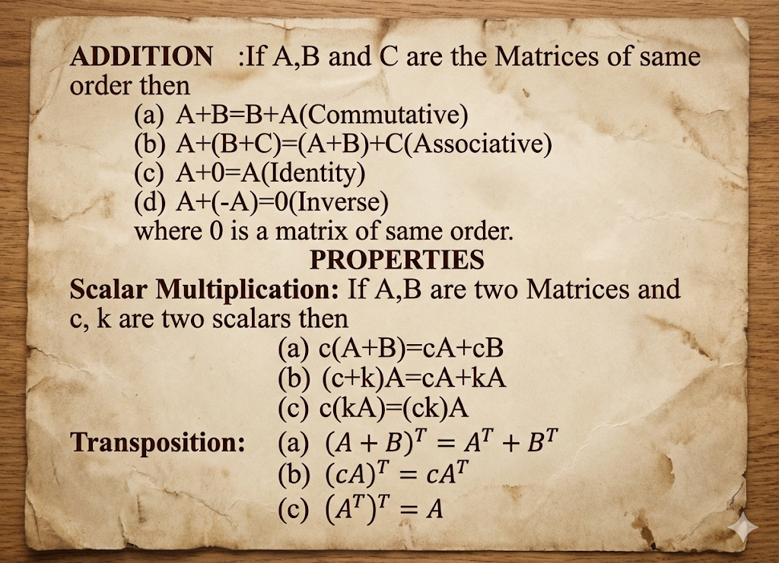
Matrix Multiplication:
Matrix multiplication is a binary operation in linear algebra where two matrices are multiplied to produce a third matrix.
If C = A X B, then the element in row i and column j of matrix C is:
C_{ij} = row i of A • column j of B
Mathematically:
C_{ij} = $\sum_{k=1}^{n}{AikBkj}$
Example:
A = $\left[\begin{matrix}1 & 2 \\ 3 & 4\end{matrix}\right]$ , B = $\left[\begin{matrix}5 & 6 \\ 7 & 8\end{matrix}\right]$
A $×$ B = $\left[\begin{matrix}19 & 22 \\ 43 & 50\end{matrix}\right]$
# Don’t Tell Me that You Don’t Know Matrix Multiplication.
# Go and See in YouTube Channel.

Upper Triangle Matrix
A square matrix that have non-zero entries only on and above the main diagonal where as any entry below the diagonal are zeros is called an upper triangular matrix.
Example: $\left[\begin{matrix}1 & 5 & 7 \\ 0 & 2 & 3 \\ 0 & 0 & -1\end{matrix}\right]$
Lower Triangular Matrix
A square matrix that have non-zero entries only on and below the main diagonal where as any entry above the main diagonal are zeros is called as lower triangular matrix.
Example: $\left[\begin{matrix}2 & 0 & 0 \\ 1 & 5 & 0 \\ -3 & 9 & 7\end{matrix}\right]$
Diagonal Matrices
These are the square matrices that can have non-zero entries only on the main diagonal and any entries above or below the diagonal are zeros.
Example: $\left[\begin{matrix}2 & 0 & 0 \\ 0 & 3 & 0 \\ 0 & 0 & -1\end{matrix}\right]$
Identity Matrix:
If all diagonal entries of a diagonal matrix are equal then it is called a scalar matrix and if all the entries are1 then it is called identity matrix or unit matrix.
Example: $\left[\begin{matrix}2 & 0 & 0 \\ 0 & 2 & 0 \\ 0 & 0 & 2\end{matrix}\right]$ Scalar Matrix, $\left[\begin{matrix}1 & 0 & 0 \\ 0 & 1 & 0 \\ 0 & 0 & 1\end{matrix}\right]$ Unit Matrix
Symmetric Matrix
A = A^{T}
Example: $\left[\begin{matrix}3 & 2 & 1 \\ 2 & -4 & 0 \\ 1 & 0 & 5\end{matrix}\right]$
Skew Symmetric Matrix
A = -A^{T}
Example: $\left[\begin{matrix}0 & 1 & 2 \\ -1 & 0 & 5 \\ -2 & -5 & 0\end{matrix}\right]$

Orthogonal Matrix
A^{T} • A = I or A^{T} = A⁻¹
Example: $\left[\begin{matrix}\cos{θ} & -\sin{θ} \\ \sin{θ} & \cos{θ}\end{matrix}\right]$

Complex Matrices
- For a given n × n square matrix A = [a_{ij}]_{n × n}, when the entries are in complex form i.e. a_{ij} = x + iy, (x, y real), then the matrix A is called Complex matrix.
- Replacing each entry with its complex conjugate ā_{ij} = x – iy (x, y real) we obtained the conjugate matrix Ā.
- Also, Ā^{T} = [ā_{ji}] is the transpose of Ā , hence the conjugate transpose of A.
- Hermitian: If Ā^{T} = A
- Skew – Hermitian: If Ā^{T} = -A
- Unitary: Ā^{T} = A⁻¹ AĀ^{T} = I
Relation Between:
- HERMITIAN MATRIX and SYMMETRIC MATRIX:
Ā^{T} = A^{T} = A
- SKEW – HERMITIAN MATRIX and SKEW – SYMMETRIC MATIX:
Ā^{T} = A^{T} = -A

- UNITARY MATRIX and ORTHOGONAL MATRIX:
Ā^{T} = A^{T} = A⁻¹
DETERMINANTS
# I THINK YOU BASIC THINGS ABOUT MATRIX? IN CLASS 12TH
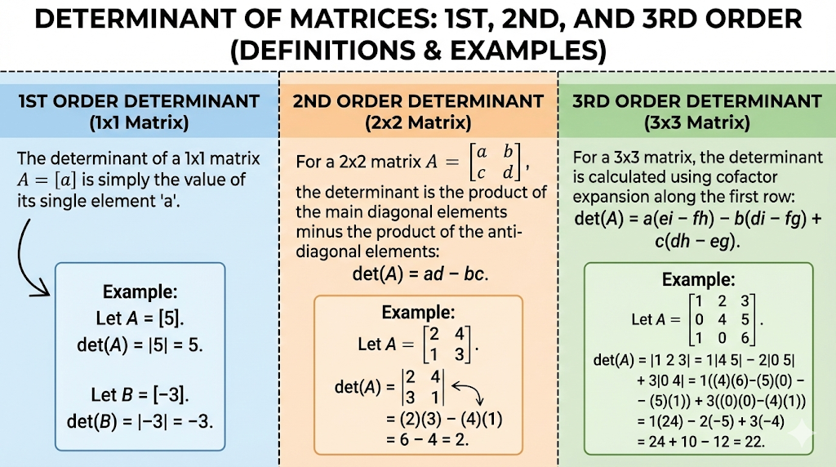
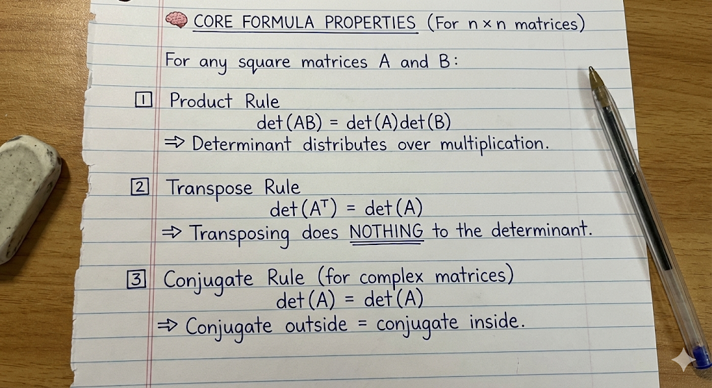
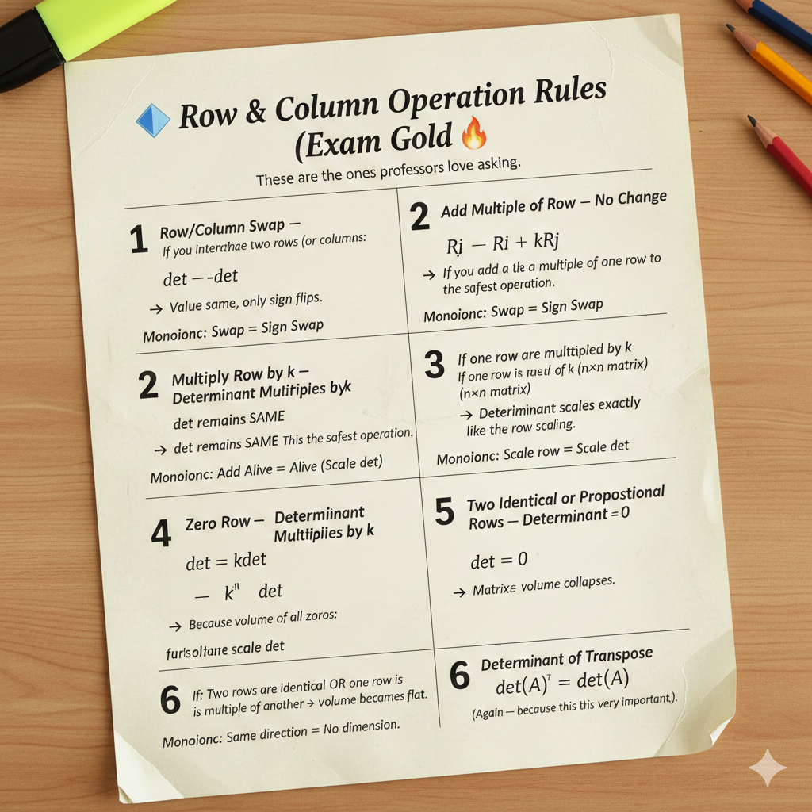

Determinant Of Triangular Matrix
The determinant of a triangle matrix is same as their product of the diagonal elements.
$\left|\begin{matrix}-3 & 0 & 0 \\ 6 & 4 & 0 \\ -1 & 2 & 5\end{matrix}\right|$ = -3 • $\left|\begin{matrix}4 & 0 \\ 2 & 5\end{matrix}\right|$ = -3 • 4 • 5 = -60

Linear Independence and Dependence
Any set of r vectors are said to be linearly dependent if there exist r numbers λ₁, λ_{2 ….} λ_{r} not all zero such that λ₁a₁ ₊ λ₂a₂ + … + λ_{r}a_{r} = 0.
If all the scalars are zero that is if all then the vectors are called linearly independent. In the other way two vectors are said to be linearly dependent if one is scalar multiple of other that is we can express one of them as a linear combination of others.
Rank Of Matrix
The maximum number of linearly independent row or column vectors of matrix is called as rank of matrix and it is denoted as rank A.
Example: A = $\left[\begin{matrix}3 & 0 & 2 & 2 \\ -6 & 42 & 24 & 54 \\ 21 & -21 & 0 & 15\end{matrix}\right]$
Rank A = 2
Determination of rank
As rank of a matrix is the maximum no. of linearly independent row vectors so this no. does not change if we change the order of the rows or multiply one of them by a nonzero scalar c or by taking a linear combination by adding multiple of a row by another row.
So, we can reduce the matrix to echelon form and after reduction the no. of non-zero rows will be the rank of the matrix.
Echelon form
Reduction of a matrix to row echelon form means the first entry of the first row will be nonzero then the first entry of 2nd row will be zero then the first two entries of the 3rd row will be zero and the no. of zeros will increase row by row up to the last row till it is reduced to row Echelon form.

Follow This Link for Understanding Rank of Matrix:
https://youtu.be/FT5H0L_fFWc?si=LsNhjFe3NJwKgnCc

Gauss Elimination Method
This is a standard elimination method to solve the linear system of equations. Let us solve the linear system of equation using gauss elimination method followed by certain steps.
Follow this link for understanding Rank of Matrix:
https://youtu.be/eDb6iugi6Uk?si=NPhwxPzrP9GpOUPV
Cases:
- Unique Solution
Since we are getting unique values of x,y so the system has unique solution. Geometrically we can say that the two equations represent two intersecting straight lines that is there is only one intersecting point so it has unique solution.
- Infinite Solution
Since we are getting infinitely many values of x, y so the system has infinite solution. Geometrically we can say that the two equations represent two straight lines which are coincident. So, it has unique solution.
- No Solution
Geometrically we can say that the two equations represent two straight lines which are parallel. So, it has no points in common. So, it has no solution.

